# Our recent City of Refuge Writers

January 2017 Lillehammer welcomed two new writers! Both writers fled together from Iran and were selected by ICORN to become the 4th and 5th City of Refuge Writer in Lillehammer. Both writers take part in the Introduction Program for Refugees in Lillehammer.

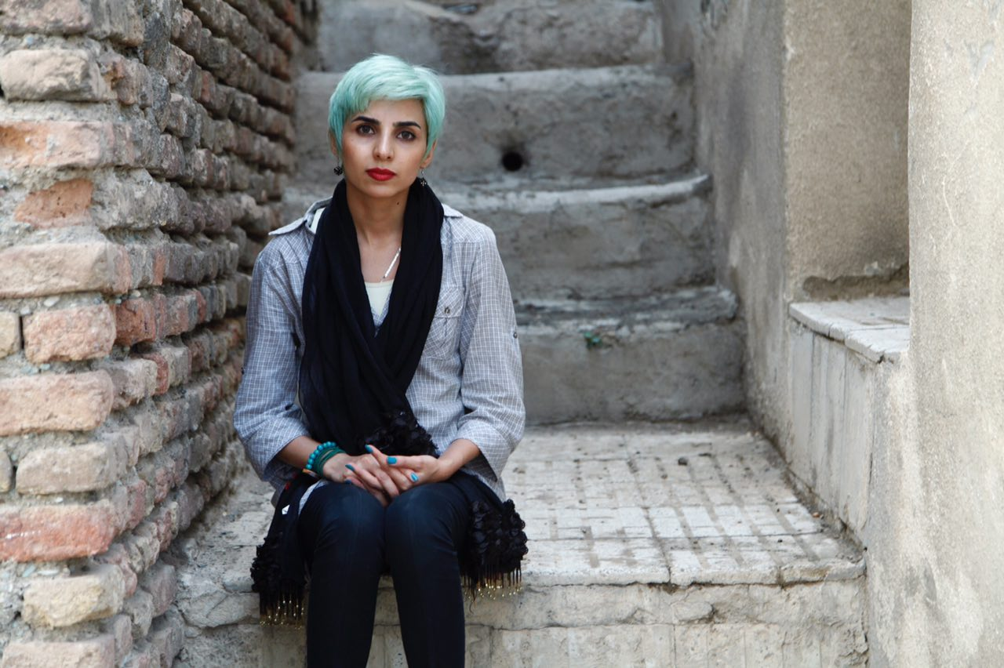**Fatemeh Ekhtesari**

Ekhtesari is a poet, a women’s rights activist and a filmmaker. She succeeded in publishing three collections of poetry in Iran and recently published a novel. She published several articles about women’s issues and made two short documentary films. Over the course of her career she has participated in underground literary workshops run by Mehdi Mousavi. Ekhtesari formed part of the ‘Resistance at My Desk’ literary exchange through which 6 poets from Iran and 6 poets from Sweden together translated the Persian poets’ work to Swedish. She currently works on a documentary about refugees.

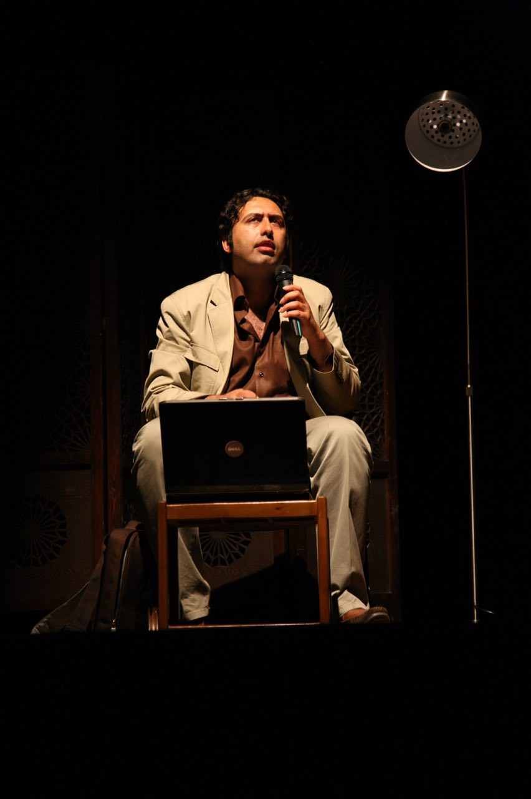**Mehdi Mousavi**

Mousavi is a prolific poet and has faced continued harassment and censorship since he first began publishing his work. Between 1999 and 2013 he published at least 10 collections of poems both in Iran and abroad. Many of his poems were published online after they were denied permission for publication. For more than 16 years he has run creative writing workshops. Mousavi is known as the leading figure of the ‘Post-modern Ghazal, the most radical poetic movement in contemporary Iran. Many of his works are banned in Iran. He just published a new collection of poems while living in Lillehammer.

Our collaborators



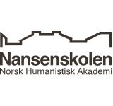 

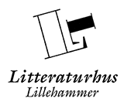    

# Do you want to know more about the City of Refuge and its writers?

**Contact:**

Fribyen Lillehammer

Kultur og Fritid

Lillehammer Kommune

Phone: +47 61 05 05 00

E- mail: postmottal@lillehammer.kommune.no

Photo frontpage: City of Refuge Writers meet the Minister of Culture Hadia Tajik at the Nansen Academy during the Literature Festival in 2013.



# **Lillehammer City of Refuge**

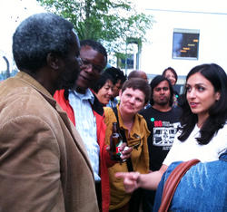

Some information about

The City of Refuge Arrangement and The City of Refuge writers



# What is a City of Refuge?

A City of Refuge is a city/municipality that has undertaken to be host to a persecuted writer for a period of at least two years. Cities of Refuge form together ICORN, International Cities of Refuge Network. ICORN is an independent membership organization. The Board is elected by the member cities and consists of representatives from the cities. The Administration Centre in Stavanger, Norway, serves as the communication hub for the independently managed ICORN Cities.

The City of Refuge arrangement was initiated by Salman Rushdie and the International Parliament of Writers (IPW) and is since 2006 administrated by ICORN.

For the writer the City of Refuge Arrangement means that he/she is safe and secured to resume his/her work as a writer. As a guest writer he or she represents the numerous other writers worldwide who are persecuted, imprisoned or killed. As a City of Refuge the city takes an important stand for the freedom of expression and contributes concrete to help people in a dangerous situation.

# What is a City of Refuge writer?

Before a person can be accepted under the City of Refuge Arrangement, he/she has to be a writer with a certain amount of literary production and proven persecuted in the home country, based on their work as a writer. The definition of ‘writer’ includes writers of fiction and non-fiction, poets, dramatists, editors, translators, publishers, journalists, newspaper illustrators and cartoonists, bloggers, song text writers, filmmakers, musicians and artists.

A City of Refuge usually accepts one writer at the time for a period of two years. City of Refuge writers who come to Norway have to take part in the Introduction Program for Refugees. City of Refuge writers in Norway have a refugee status and get a permanent residence permit. Writers who are finished with their two years period can stay in their City of Refuge and will continue to be part of the City of Refuge Network.

Lillehammer City of Refuge

The local Council of Lillehammer decided in March 2008 to become a city of Refuge for writers who are persecuted in their home country. With this decision the city undertook a special responsibility in the fight for freedom of expression.

Lillehammer City of Refuge is a collaboration, between Lillehammer Municipality, The Norwegian Festival of Literature, Lillehammer Library, Lillehammer House of Literature, Lillehammer University College, Nansen Academy and the Nansen Center for Peace and Dialogue, and with the regions remaining cultural environment.

Our task as a City of Refuge is to offer the writers a safe place to live, financial security, a professional and social network and the possibility to practice their literary work.

The participation with ICORN gives us access to a literary and cultural network in Europe and other parts of the world. This is of great importance to Lillehammer as a Cultural City.

# Cities of Refuge

There are 65 cities of refuge in connection with ICORN throughout the world and more than 170 writers and artist have found refuge in an ICORN city. 14 of these cities are in Norway: Bergen, Bø, Drøbak, Harstad, Haugesund, Kristiansand, Levanger, Lillehammer, Molde, Oslo, Skien, Stavanger, Tromsø og Trondheim.

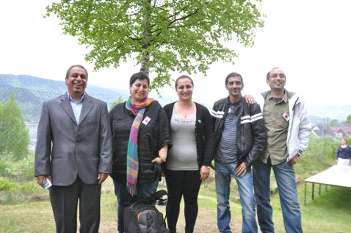

City of Refuge Writers at the Nansen Academy gardenparty in 2014. Foto: Anne-Grethe Fostås.

# Our City of Refuge Writers

**Francisca Prudence Uriri**

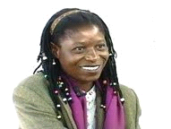

May 2008 Lillehammer welcomed its first writer of refuge, Francisca Prudence Uriri.

She is an award winning film producer from Zimbabwe. She had to flee from her home country because of her work.

In Lillehammer she started her project with the film «The Storm – Healing & Justice in Zimbabwe». Among other activities she participated at the Norwegian Festival of Literature. Uriri moved to Tromsø where she works fulltime at the department of film at the University of Tromsø.

**Huynh Ba Hai**

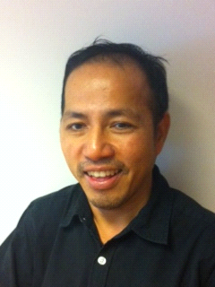

February 2011 our second City of Refuge Writer, the blogger Huynh Ba Hai, arrived from Vietnam. Ba Hai has since he arrived continued his blogging for international and local newspapers and magazines in his region. He finished his City of Refuge period in February 2013. He lives still at Lillehammer together with his family and works on a biographical novel.

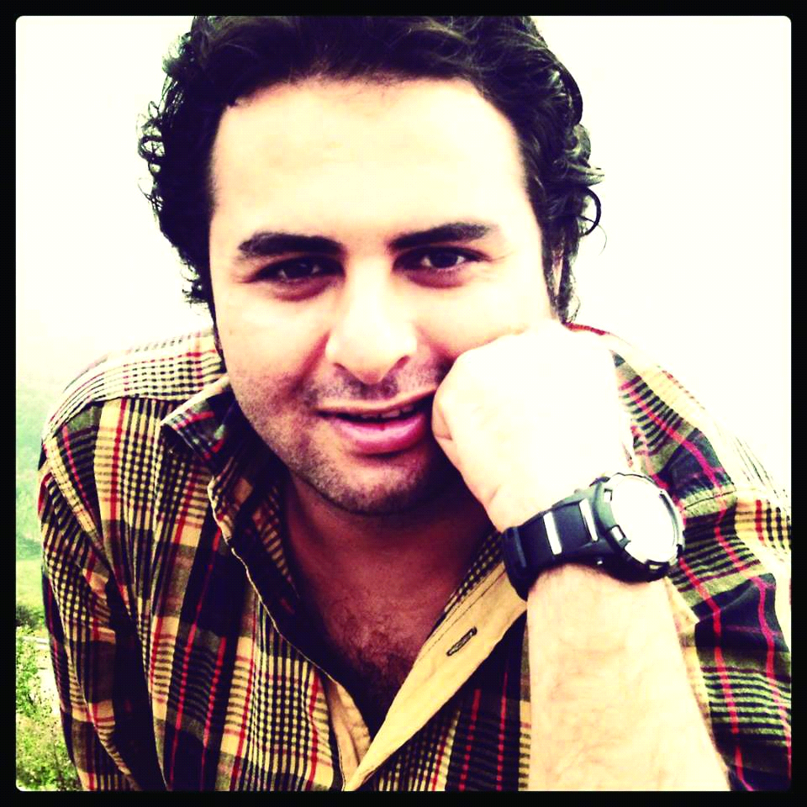

**Nama Jafari**

September 2014, Nama Jafari arrived at Lillehammer and he is our third writer of refuge. He comes from Iran and is a poet, blogger, author and internet editor. Jafari is very engaged in the topic of freedom of expression and works actively against internet censorship in Iran. He finished his City of refuge period December 2016 and he is about to publish a collection of his Iranian poems in Norwegian.